# **WordPress speed optimization tutorial**

# **Fix Above the Fold, Render Blocking & Defer CSS & JavaScript WordPress**

These are the optimization needs to be done:

1. Create a child theme
2. Above the fold (critical) CSS, combine, minify and load asynchronously
3. Minify, combine and defer JavaScript
4. Change the size, compress and lazy load images
5. Serve images in modern formats
6. Ensure text remains visible during webfont load
7. Files expiration date or leverage browser caching
8. Caching solution

# **1. Create the child theme**

Creating a child theme in WordPress is so easy.

# **2. Above the fold (critical) CSS, combine, minify and load asynchronously**

* You can check the critical css on this website. <https://www.sitelocity.com/critical-path-css-generator>
* Add the css and js file in <head></head> tags.

<head>

<link rel="stylesheet" href="style.css" async>

<script defer src="jquery.min.js" type="text/javascript"></script>

</head>

# **3. Minify, combine and defer JavaScript**

Keep in mind, you can’t fix **render-blocking JavaScript** from third-party apps (ex. Google fonts) or you should host them on your website, render blocking Google fonts won’t be a problem because they are cached by a big number of websites and will load so fast.

1. Minify/combine CSS
2. Minify/combine JS
3. LazyLoad for images
4. Optimize CSS delivery (critical CSS)
5. Defer JS

**1. Minify/combine CSS**

Minifier the needed css <https://www.minifier.org/>

**2. Minify/combine JS**

Minifier the needed js <https://www.minifier.org/>

**3. LazyLoad for images**

* Add the lazysizes script to the page
* You should add the “lazyload” class for all images given below the code.

Add the script inside of <head> tag

**<script type="text/javascript">**

**$(document).ready(function() {**

**$("img").addClass("lazyload");**

**});**

**</script>**

Html code:

**<img data-src="images/flower3.png" class="lazyload" alt="">**

* After calling the “lazysizes.min.js” file.

**<script src="https://andersonautobodyut.com/wp-content/themes/anderson-autobody/assets/lazysizes.min.js" async></script>**

**4. Optimize CSS delivery (critical CSS) - How to load CSS files asynchronously in WordPress**

* Add the code below into function.php at the end. This code will add “media='all'” for all css files.

**function load_scripts_and_styles() {**

**// register loadCSS**

**wp_register_script( 'load-css-async', 'https://andersonautobodyut.com/wp-content/themes/anderson-autobody/assets/js/loadCSS.js', array(), '', false );**

**// enqueue loadCSS**

**wp_enqueue_script( 'load-css-async' );**

**}**

**add_action('wp_enqueue_scripts', 'load_scripts_and_styles', 999);**

* Upload the **loadCSS.js loadCSS.js** file to your theme folder.

**4. Defer JS**

**Defer JavaScript manually with function.php**

Add the code below into function.php at the end. This code will show all JavaScripts that load in the header and the footer:

**Method: 1**

After you finish deferring the Javascript remove the code above from **function.php**

**add_action( 'wp_head', 'show_scripts_in_header', 9999 );**

**add_action( 'wp_footer', 'show_scripts_in_footer', 9999 );// JavaScripts appear on the top, before the header**

**function show_scripts_in_header(){**

**global $wp_scripts;**

**echo '<pre>'; print_r($wp_scripts->done); echo '</pre>';**

**}// JavaScripts appear on the bottom, after the footer**

**function show_scripts_in_footer(){**

**global $wp_scripts;**

**echo '<pre>'; print_r($wp_scripts->done); echo '</pre>';**

**}**

You will get something like this:

**Header:**

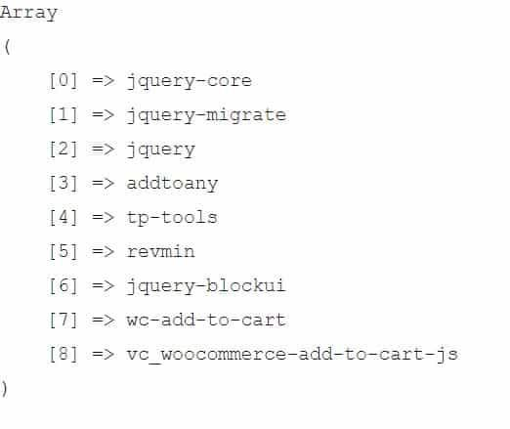

**Footer:**

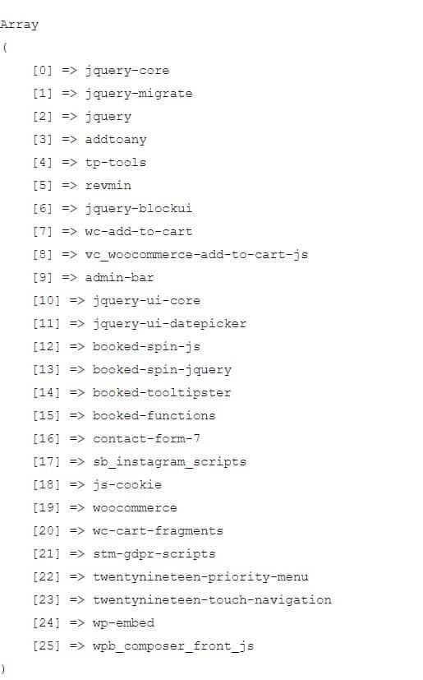

Choose which JavaScript file you want to defer with the following code:

**add_filter( 'script_loader_tag', 'defer_scripts_myhostingfacts', 10, 3 );**

**function defer_scripts_myhostingfacts( $tag, $handle, $src ) { // The handles of the enqueued scripts we want to defer**

**$defer_scripts = array('here', 'is', 'an', 'example', 'change',**

**'with-scripts-that-are-in-header-and-footer-from-previous-code',**

**'actual-example', 'vc_woocommerce-add-to-cart-js'); if ( in_array( $handle, $defer_scripts ) ) {**

**return '<script src="' . $src . '" defer="defer" type="text/javascript"></script>' . "\n";**

**}**

**return $tag;**

**}**

jQuery is best to load in the head because a lot of plugins and themes need jQuery to load before loading some styles, front-end animations or some validation etc…

**//The code below remove the scripts from head and add them in footer**

**function remove_head_scripts() {**

**remove_action(‘wp_head’, ‘wp_print_scripts’);**

**remove_action(‘wp_head’, ‘wp_print_head_scripts’, 9);**

**remove_action(‘wp_head’, ‘wp_enqueue_scripts’, 1);add_action(‘wp_footer’, ‘wp_print_scripts’, 5);**

**add_action(‘wp_footer’, ‘wp_enqueue_scripts’, 5);**

**add_action(‘wp_footer’, ‘wp_print_head_scripts’, 5);**

**}**

**add_action( ‘wp_enqueue_scripts’, ‘remove_head_scripts’ );**

**//Test thoroughly if everything works**

**(OR)**

**Method: 2**

Below is the code for adding the **“Defer”** for all js files.

**function defer_parsing_of_js( $url ) {**

**if ( is_user_logged_in() ) return $url; //don't break WP Admin**

**if ( FALSE === strpos( $url, '.js' ) ) return $url;**

**if ( strpos( $url, 'jquery.js' ) ) return $url;**

**return str_replace( ' src', ' defer src', $url );**

**}**

**add_filter( 'script_loader_tag', 'defer_parsing_of_js', 10 );**

# 

# **4. Serve images in modern formats**

* Convert the jpeg, png, jpg image format to WebP using this site <https://image.online-convert.com/convert-to-webp>
* Add the code below into function.php at the end. This code is used to show the WebP format image in WordPress media.

function webp_upload_mimes( $existing_mimes ) {

// add webp to the list of mime types

$existing_mimes['webp'] = 'image/webp';

// return the array back to the function with our added mime type

return $existing_mimes;

}

add_filter( 'mime_types', 'webp_upload_mimes' );

//** * Enable preview / thumbnail for webp image files.*/

function webp_is_displayable($result, $path) {

if ($result === false) {

$displayable_image_types = array( IMAGETYPE_WEBP );

$info = @getimagesize( $path );

if (empty($info)) {

$result = false;

} elseif (!in_array($info[2], $displayable_image_types)) {

$result = false;

} else {

$result = true;

}

}

return $result;

}

add_filter('file_is_displayable_image', 'webp_is_displayable', 10, 2);

# **5. Ensure text remains visible during webfont load**

* **How to avoid showing invisible text**

The easiest way to avoid showing invisible text while custom fonts load is to temporarily show a system font. By including **font-display: swap** in your **@font-face** style, you can avoid FOIT in most modern browsers:

@font-face {

font-family: 'Pacifico';

font-style: normal;

font-weight: 400;

src: local('Pacifico Regular'), local('Pacifico-Regular'), url(https://fonts.gstatic.com/s/pacifico/v12/FwZY7-Qmy14u9lezJ-6H6MmBp0u-.woff2) format('woff2');

font-display: swap;

}

* **Preload web fonts**

Use <link rel="preload" as="font"> to fetch your font files earlier.

* **Google Fonts**

Add the **&display=swap** parameter to the end of your Google Fonts URL:

<link href="https://fonts.googleapis.com/css?family=Roboto:400,700&display=swap" rel="stylesheet">

# **6. Change the size, compress and lazy load images**

* Image optimization can be done with Photoshop or online image compression.
* Add the lazysizes script to the page
* You should add the “lazyload” class for all images given below the code.

Add the script inside of <head> tag

**<script type="text/javascript">**

**$(document).ready(function() {**

**$("img").addClass("lazyload");**

**});**

**</script>**

Html code:

**<img data-src="images/flower3.png" class="lazyload" alt="">**

* After calling the “lazysizes.min.js” file.

**<script src="https://andersonautobodyut.com/wp-content/themes/anderson-autobody/assets/lazysizes.min.js" async></script>**

# **7. Files expiration date or leverage browser caching**

Go to your web hosting file manager and go to the root of your website, there will be a file .htaccess right-click opens it with the editor (depending on your web hosting you may need to select and or from right to click edit). If you can’t find .htaccess you need to unhide system files.

Copy this and paste in .htaccess

<FilesMatch "index\.(html|htm)$">

AddDefaultCharset UTF-8

<ifModule mod_headers.c>

FileETag None

Header unset ETag

Header set Cache-Control "max-age=0, no-cache, no-store, must-revalidate"

Header set Pragma "no-cache"

Header set Expires "Mon, 29 Oct 1923 20:30:00 GMT"

</ifModule>

</FilesMatch>

<IfModule mod_deflate.c>

AddType x-font/woff .woff

AddType x-font/ttf .ttf

AddOutputFilterByType DEFLATE image/svg+xml

AddOutputFilterByType DEFLATE text/plain

AddOutputFilterByType DEFLATE text/html

AddOutputFilterByType DEFLATE text/xml

AddOutputFilterByType DEFLATE text/css

AddOutputFilterByType DEFLATE text/javascript

AddOutputFilterByType DEFLATE application/xml

AddOutputFilterByType DEFLATE application/xhtml+xml

AddOutputFilterByType DEFLATE application/rss+xml

AddOutputFilterByType DEFLATE application/javascript

AddOutputFilterByType DEFLATE application/x-javascript

AddOutputFilterByType DEFLATE application/x-font-ttf

AddOutputFilterByType DEFLATE x-font/ttf

AddOutputFilterByType DEFLATE application/vnd.ms-fontobject

AddOutputFilterByType DEFLATE font/opentype font/ttf font/eot font/otf

</IfModule>

<FilesMatch "\.(webm|ogg|mp4|ico|pdf|flv|jpg|jpeg|png|gif|webp|js|css|swf|x-html|css|xml|js|woff|woff2|otf|ttf|svg|eot)(\.gz)?$">

<IfModule mod_expires.c>

AddType application/font-woff2 .woff2

AddType application/x-font-opentype .otf

ExpiresActive On

ExpiresDefault A0

ExpiresByType video/webm A10368000

ExpiresByType video/ogg A10368000

ExpiresByType video/mp4 A10368000

ExpiresByType image/webp A10368000

ExpiresByType image/gif A10368000

ExpiresByType image/png A10368000

ExpiresByType image/jpg A10368000

ExpiresByType image/jpeg A10368000

ExpiresByType image/ico A10368000

ExpiresByType image/svg+xml A10368000

ExpiresByType text/css A10368000

ExpiresByType text/javascript A10368000

ExpiresByType application/javascript A10368000

ExpiresByType application/x-javascript A10368000

ExpiresByType application/font-woff2 A10368000

ExpiresByType application/x-font-opentype A10368000

ExpiresByType application/x-font-truetype A10368000

</IfModule>

<IfModule mod_headers.c>

Header set Expires "max-age=A10368000, public"

Header unset ETag

Header set Connection keep-alive

FileETag None

</IfModule>

</FilesMatch>

Added new file:  
1. /wp-content/themes/anderson-autobody/assets/js/lazysizes.min.js  
2. /wp-content/themes/anderson-autobody/assets/js/loadCSS.js  
  
I have removed the CDN fontawesome css and added the css in server  
3. /wp-content/themes/anderson-autobody/assets/font-awesome.css  
  
And removed to call the third party fonts, And add the fonts in server  
4. /wp-content/themes/anderson-autobody/assets/fonts  
  
5. /wp-content/themes/anderson-autobody/functions.php